ЛАБОРАТОРНА РОБОТА № 3
Часткові представлення. Робота з View Components. Навігація. Фільтрація. Використання сесії.
Варіант №8
Мета: отримати навички роботи з частковими представленнями, навчитися працювати з параметрами рядку запиту, набути навичок роботи з сесіями.
Завдання 1. Створення часткового представлення (Partial View)
- У папці Views/Shared створіть .cshtml файл для одиничного елементу зі списку сутностей (для SportsStore це буде ProductSummary.cshtml)
- Перемістіть код для одиничного елементу з загального View Index.cshtm в створений файл.
- Використайте створений Partial View в Index.cshtml за допомогою Tag Helper’а <partial>
Лістинг _FilmSummary.cshtml
@model AbsoluteCinema.Models.Film

<div class="col">
<div class="card h-100">
@if (!string.IsNullOrEmpty(Model.PosterUrl))
{
<img src="@Model.PosterUrl" class="card-img-top" alt="@Model.Title" />
}
<div class="card-body">
<h5 class="card-title">@Model.Title (@Model.ReleaseYear)</h5>
<p class="card-text">@Model.Description</p>
<p class="mb-1"><strong>Genre:</strong> @Model.Genre</p>
<p class="mb-1"><strong>Price:</strong> @Model.TicketPrice.ToString("c")</p>
</div>
</div>
</div>
Лістинг Index.cshtml
@model AbsoluteCinema.Models.ViewModels.FilmsListViewModel

<h2 class="mb-4">Films</h2>

<div class="row row-cols-1 row-cols-md-2 g-4">
@foreach (var film in Model.Films)
{
<partial name="_FilmSummary" model="film" />
}
</div>

<nav aria-label="Page navigation" class="mt-4">
<ul class="pagination justify-content-center">
@for (int i = 1; i <= Model.PagingInfo.TotalPages; i++)
{
var activeClass = i == Model.PagingInfo.CurrentPage ? "active" : "";
<li class="page-item @activeClass">
<a class="page-link" asp-action="Index" asp-controller="Home" asp-route-page="@i">@i</a>
</li>
}
</ul>
</nav>
Лістинг HomeController
using Microsoft.AspNetCore.Mvc;
using AbsoluteCinema.Models;
using AbsoluteCinema.Models.ViewModels;
using System.Linq;

namespace AbsoluteCinema.Controllers
{
public class HomeController : Controller
{
private readonly ICinemaRepository repository;
private const int PageSize = 3;

public HomeController(ICinemaRepository repo)
{
repository = repo;
}

public IActionResult Index(string? genre, int page = 1)
{
var filmsQuery = repository.Films
.Where(f => genre == null || f.Genre == genre)
.OrderBy(f => f.Title);

var viewModel = new FilmsListViewModel
{
Films = filmsQuery
.Skip((page - 1) * PageSize)
.Take(PageSize)
.ToList(),
PagingInfo = new PagingInfo
{
CurrentPage = page,
ItemsPerPage = PageSize,
TotalItems = filmsQuery.Count()
}
};

ViewBag.SelectedGenre = genre;
ViewBag.Genres = repository.Films
.Select(f => f.Genre)
.Distinct()
.OrderBy(g => g)
.ToList();

return View(viewModel);
}
}
}
Лістинг Index.cshtml
@model AbsoluteCinema.Models.ViewModels.FilmsListViewModel

@{
ViewData["Title"] = "Home";
}

<div class="row">
<div class="col-3">
<h3>Genres</h3>
<partial name="_GenreList" model="ViewBag.Genres" view-data="ViewData" />
</div>

<div class="col-9">
<h2 class="mb-4">Films</h2>

<div class="row row-cols-1 row-cols-md-2 g-4">
@foreach (var film in Model.Films)
{
<partial name="_FilmSummary" model="film" />
}
</div>

<nav aria-label="Page navigation" class="mt-4">
<ul class="pagination justify-content-center">
@for (int i = 1; i <= Model.PagingInfo.TotalPages; i++)
{
var activeClass = i == Model.PagingInfo.CurrentPage ? "active" : "";
<li class="page-item @activeClass">
<a class="page-link"
asp-action="Index"
asp-controller="Home"
asp-route-page="@i"
asp-route-genre="@ViewBag.SelectedGenre">@i</a>
</li>
}
</ul>
</nav>
</div>
</div>
Лістинг NavigationMenuViewComponent
using Microsoft.AspNetCore.Mvc;
using AbsoluteCinema.Models;
using System.Linq;

namespace AbsoluteCinema.Components
{
public class NavigationMenuViewComponent : ViewComponent
{
private readonly ICinemaRepository repository;

public NavigationMenuViewComponent(ICinemaRepository repo)
{
repository = repo;
}

public IViewComponentResult Invoke()
{
var genres = repository.Films
.Select(f => f.Genre)
.Distinct()
.OrderBy(g => g);

ViewBag.SelectedGenre = RouteData?.Values["genre"];

return View(genres);
}
}
}
Лістинг _FilmSummary.cshtml
@model AbsoluteCinema.Models.Film

<div class="col">
<div class="card h-100">
@if (!string.IsNullOrEmpty(Model.PosterUrl))
{
<img src="@Model.PosterUrl" class="card-img-top" alt="@Model.Title" />
}
<div class="card-body">
<h5 class="card-title">@Model.Title (@Model.ReleaseYear)</h5>
<p class="card-text">@Model.Description</p>
<p class="mb-1"><strong>Genre:</strong> @Model.Genre</p>
<p class="mb-1"><strong>Price:</strong> @Model.TicketPrice.ToString("c")</p>
</div>
</div>
</div>
Лістинг _GenreList.cshtml
@model IEnumerable<string>

<div class="list-group">
<a asp-controller="Home" asp-action="Index"
class="list-group-item list-group-item-action @(ViewBag.SelectedGenre == null ? "active" : "")">
All Films
</a>

@foreach (var genre in Model)
{
<a asp-controller="Home"
asp-action="Index"
asp-route-genre="@genre"
class="list-group-item list-group-item-action @(ViewBag.SelectedGenre == genre ? "active" : "")">
@genre
</a>
}
</div>
Лістинг _Layout.cshtml
@addTagHelper *, Microsoft.AspNetCore.Mvc.TagHelpers
<!DOCTYPE html>
<html lang="en">
<head>
<meta charset="utf-8" />
<meta name="viewport" content="width=device-width, initial-scale=1" />
<title>AbsoluteCinema - @ViewData["Title"]</title>

<link rel="stylesheet" href="~/lib/bootstrap/css/bootstrap.min.css" />
</head>
<body>
<nav class="navbar navbar-expand-lg navbar-dark bg-dark mb-4">
<div class="container">
<a class="navbar-brand" asp-controller="Home" asp-action="Index">AbsoluteCinema</a>
<button class="navbar-toggler" type="button" data-bs-toggle="collapse" data-bs-target="#navbarNav">
<span class="navbar-toggler-icon"></span>
</button>
<div class="collapse navbar-collapse" id="navbarNav">
<ul class="navbar-nav ms-auto">
<li class="nav-item">
<a class="nav-link @(ViewData["Title"]?.ToString() == "Home" ? "active" : "")"
asp-controller="Home" asp-action="Index">
Home
</a>
</li>
<li class="nav-item">
<a class="nav-link @(ViewData["Title"]?.ToString() == "About" ? "active" : "")"
asp-controller="Home" asp-action="About">
About
</a>
</li>
</ul>
</div>
</div>
</nav>

<div class="container">
@RenderBody()
</div>

<footer class="bg-dark text-light py-3 mt-4">
<div class="container text-center">
&copy; 2025 AbsoluteCinema. All rights reserved.
</div>
</footer>

<script src="~/lib/bootstrap/js/bootstrap.bundle.min.js"></script>
</body>
</html>
Лістинг _Navbar.cshtml
@model IEnumerable<string>

<div class="list-group">
<a asp-controller="Home" asp-action="Index"
class="list-group-item list-group-item-action @(ViewBag.SelectedGenre == null ? "active" : "")">
All Films
</a>

@foreach (var genre in Model)
{
<a asp-controller="Home"
asp-action="Index"
asp-route-genre="@genre"
class="list-group-item list-group-item-action @(ViewBag.SelectedGenre == genre ? "active" : "")">
@genre
</a>
}
</div>
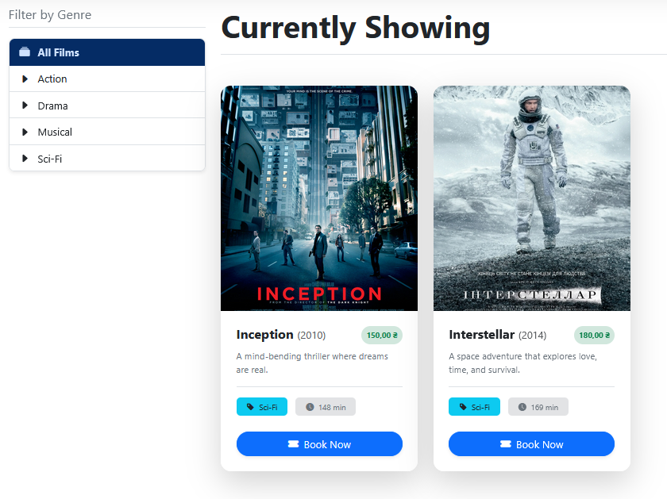
Рис. 1. Фільтрування по секціям
Завдання 3. Сесії
Реалізуйте функціональність відповідно до варіанту вашого проекту з використанням механізму сесії (табл. 3.1.)
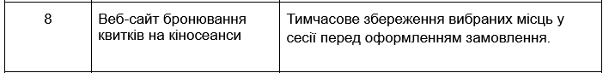
Лістинг BookingController.cs
using Microsoft.AspNetCore.Mvc;
using AbsoluteCinema.Helpers;
using AbsoluteCinema.Models;
using System.Linq;

namespace AbsoluteCinema.Controllers
{
public class BookingController : Controller
{
private const string SeatsSessionKey = "SelectedSeats";

public IActionResult SelectSeat(int row, int number)
{
if (BookingDataStore.GetBookedSeats().Any(s => s.Row == row && s.Number == number))
{
return Ok(new { success = false, message = "Seat is permanently booked." });
}

var seats = HttpContext.Session.GetObject<List<Seat>>(SeatsSessionKey) ?? new List<Seat>();

var existingSeat = seats.FirstOrDefault(s => s.Row == row && s.Number == number);
if (existingSeat != null)
{
seats.Remove(existingSeat);
}
else
{
seats.Add(new Seat { Row = row, Number = number });
}

HttpContext.Session.SetObject(SeatsSessionKey, seats);
return Ok(new { success = true, selected = seats });
}

public IActionResult GetSelectedSeats()
{
var seats = HttpContext.Session.GetObject<List<Seat>>(SeatsSessionKey) ?? new List<Seat>();
return Json(seats);
}

public IActionResult Confirm()
{
var seats = HttpContext.Session.GetObject<List<Seat>>(SeatsSessionKey) ?? new List<Seat>();

if (seats.Any())
{
BookingDataStore.AddPermanentBookings(seats);

HttpContext.Session.Remove(SeatsSessionKey);
TempData["Message"] = $"Booking confirmed for {seats.Count} seat(s)!";
}
else
{
TempData["Message"] = "No seats were selected for booking.";
}

return RedirectToAction("Index", "Home");
}

public IActionResult SelectSeats()
{
return View();
}
}
}
Лістинг SessionExtensions.cs
using Microsoft.AspNetCore.Http;
using System.Text.Json;

namespace AbsoluteCinema.Helpers
{
public static class SessionExtensions
{
public static void SetObject<T>(this ISession session, string key, T value)
{
session.SetString(key, JsonSerializer.Serialize(value));
}

public static T? GetObject<T>(this ISession session, string key)
{
var value = session.GetString(key);
return value == null ? default : JsonSerializer.Deserialize<T>(value);
}
}
}
Лістинг SelectSeats.cshtml
@using AbsoluteCinema.Models
@{
ViewData["Title"] = "Seat Booking";

var permanentBookedSeats = BookingDataStore.GetBookedSeats().ToList();
}

<h2 class="mb-4">🎟 Select Your Seats</h2>
<h4 class="mb-5 text-muted">Screen is here ⬆️</h4>

@if (TempData["Message"] != null)
{
<div class="alert alert-success">@TempData["Message"]</div>
}

<div id="seat-container" class="d-flex flex-column gap-2 p-5 border rounded-3 bg-light">
@for (int row = 1; row <= 3; row++)
{
<div class="d-flex justify-content-center gap-2">
@for (int number = 1; number <= 5; number++)
{
var isBooked = permanentBookedSeats.Any(s => s.Row == row && s.Number == number);
var baseClass = isBooked ? "seat-booked" : "seat-available";

<div class="seat @baseClass"
data-row="@row"
data-number="@number"
data-is-booked="@isBooked.ToString().ToLower()">
</div>
}
</div>
}
</div>

<a asp-action="Confirm" class="btn btn-success mt-4">Confirm Booking</a>

@section Scripts {
<script>
document.querySelectorAll('.seat-available').forEach(btn => {
btn.addEventListener('click', async () => {
const row = btn.dataset.row;
const number = btn.dataset.number;

const response = await fetch(`/Booking/SelectSeat?row=${row}&number=${number}`, {
method: "POST"
});

if (response.ok) {
btn.classList.toggle('seat-selected');
}
});
});

async function loadSelectedSeats() {
const response = await fetch('/Booking/GetSelectedSeats');
const selectedSeats = await response.json();

selectedSeats.forEach(seat => {
const seatElement = document.querySelector(`.seat-available[data-row="${seat.row}"][data-number="${seat.number}"]`);

if (seatElement) {
seatElement.classList.add('seat-selected');
}
});
}

loadSelectedSeats();
</script>
}

<style>
.seat {
width: 40px;
height: 40px;
margin: 5px;
border-radius: 5px;
display: flex;
align-items: center;
justify-content: center;
font-size: 0;
transition: all 0.2s ease-in-out;
border: 1px solid #ced4da;
}

.seat-available {
background-color: #f8f9fa;
cursor: pointer;
}

.seat-available:hover {
background-color: #e9ecef;
box-shadow: 0 0 5px rgba(0, 123, 255, 0.5);
}

.seat-booked {
background-color: #dc3545;
cursor: not-allowed;
opacity: 0.8;
border-color: #dc3545;
}

.seat-selected {
background-color: #28a745;
border-color: #28a745;
box-shadow: 0 0 5px rgba(40, 167, 69, 0.7);
}

#seat-container::before {
content: "SCREEN";
display: block;
text-align: center;
margin-bottom: 20px;
padding: 10px;
background-color: #343a40;
color: white;
font-weight: bold;
border-radius: 5px;
letter-spacing: 5px;
}
</style>
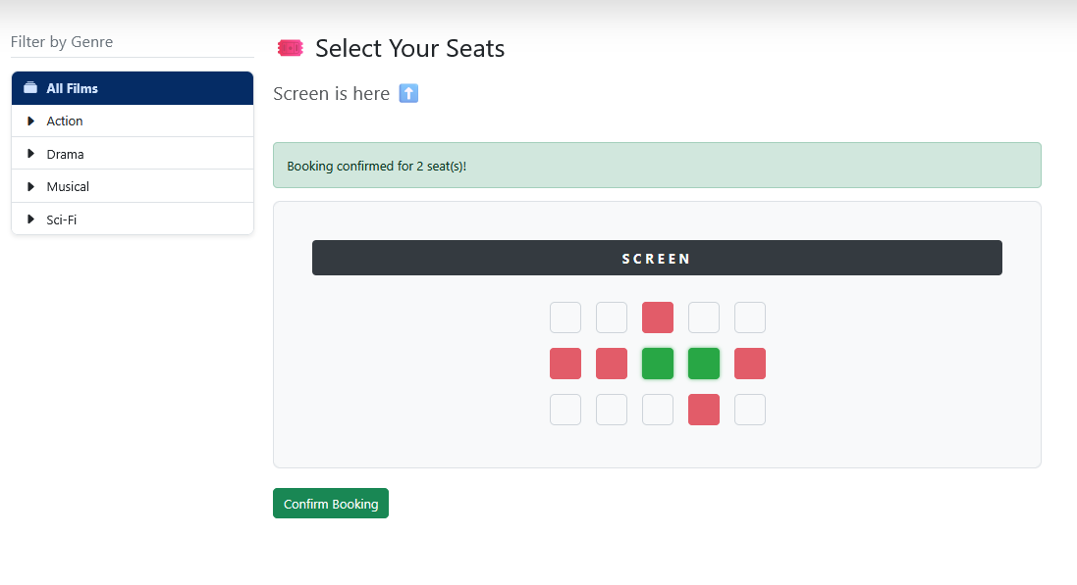
Рис. 2. Бронювання місць
Висновок: я отримав навички роботи з частковими представленнями, навчився працювати з параметрами рядку запиту, набув навичок роботи з сесіями.

